eXPLORE

Consider the following two statements:
- If Briony is texting, then she is using a cellphone.
- If Briony is using a cellphone, then she is texting.

How do these statements relate to each other? Are they both true?

Example #1
Consider the following conditional statement:
- If it is Saturday, then I will go to the movies.”
Verify when this conditional statement is true or false. Confirm your results with a Venn diagram.

eXAMPLE 2
Determine whether the converse of the conditional statement in Example 1 is true or false.

PRACTICE1
Consider the conditional statement “If I am reading, then I am studying.”
- Write the hypothesis and the conclusion.

- Is the conditional statement true? If it is false, provide a counterexample.

- Write the converse. Is the converse true? If it is false, provide a counterexample if possible.

PRACTICE 2

Consider the following conditional statement: “If an integer ends in 0, then it is divisible by 5.”
- Write the hypothesis and the conclusion.

- Is the conditional statement true? If it is false, provide a counterexample.

- Write the converse. Is the converse true? If it is false, provide a counterexample.

PRACTICE 3

- Consider the following conditional statement in relation to the Venn diagram: “If an integer is divisible by 9, then it is divisible by 3.” Is this statement true or false?

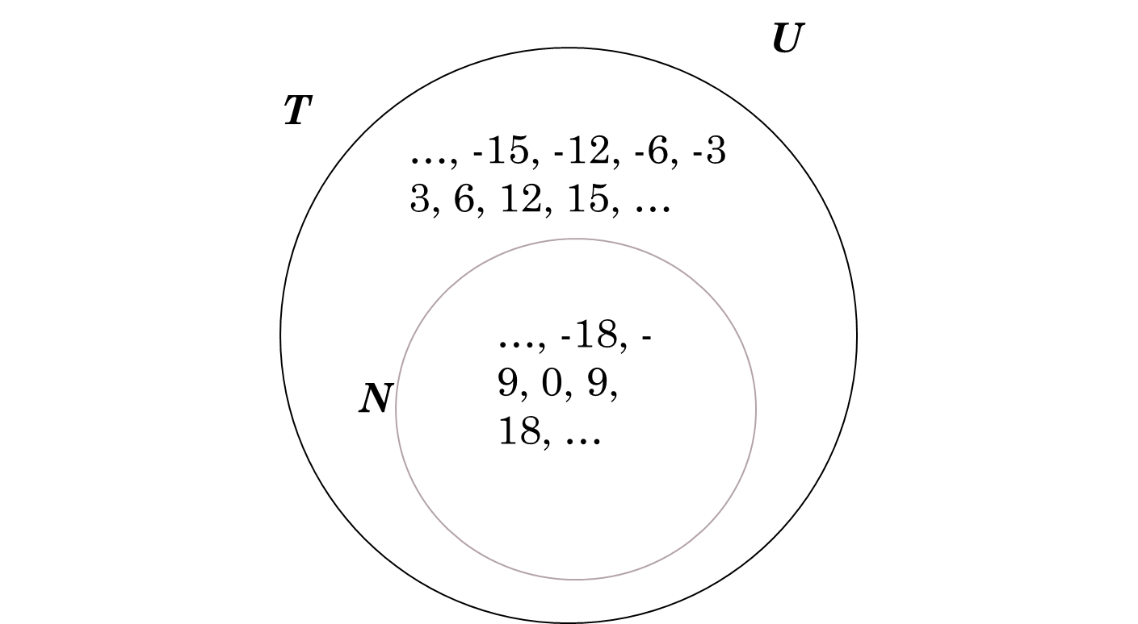

- Write the converse and say whether it is true or false. If it is false, provide a counterexample.

PRACTICE 4

A square has four equal sides.

- Write this statement in “if p then q” form.

- Write the converse of your conditional statement in part a)

- Is each statement true or false?

  - Original statement: _________________

  - Converse statement: _________________

- Is the statement biconditional? Explain.

