eXPLORE

Sarah conducted a survey of teen gaming preferences. Here are her results:
- 20 teens playing online games
- 20 play on a game console.
- 20 play games on their cellphone.

She surveyed only 31 teens. How can this be?

INVESTIGATE THE MATH
Rachel surveyed Grade 12 students about how they communicated with friends over the previous week.
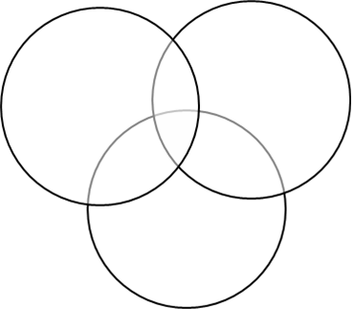
- 66% called on a cellphone.
- 76% texted.
- 34% used a social networking site.
- 56% called on a cellphone and texted.
- 18% called on a cellphone and used a social networking site.
- 19% texted and used a social networking site.
- 12% used all three forms of communication.
What percent of students used at least one of these three forms of communication?
- C={cellphone}, T={texted}, S={social networking}
  - What does the universal set U represent in this situation?
  - Record the percent of students who used all three forms

- Determine the percent of students who texted and used a social networking site, but did not call on a cellphone.

- Determine the percent of students who called on a cellphone and used a social networking site, but did not text. Determine the percent of students who called on a cellphone and texted, but did not use a social networking site.
- Determine the percent of students who only called on a cellphone, only texted, or only used a social networking site.

- Determine the percent of students who used at least one of these three forms of communication.

- Serge claims that the Principle of Inclusion and Exclusion can be used to develop a formula for $n(S∪T∪C)$ as follows:
$$n\left(S∪T∪C\right)=n\left(S\right)+n\left(T\right)+n\left(C\right)-n\left(S∩T\right)-n\left(S∩C\right)-n\left(T∩C\right)+n(S∩T∩C)$$
Does this formula give the same answer as in part E? Explain.

- Determine the percent of students who called on a cellphone or texted, but did not use a social networking site. Express your result in set notation

- How would your Venn diagram change if 16% of the students had used all three forms of communication?

eXAMPLE
In a Grade 12 math class:

- 25 students have a tablet, an MP3 player, or a cellphone.
- 15 students have a tablet.
- 14 students have an MP3 player
- 13 students have a cellphone
- 5 students have a table5 and an MP3 player
- 4 students have a tablet and a cellphone
- 2 students have an MP3 player and a cellphone

- How many students have all three devices?

- How many students have only one device?

PRACTICE1
The three circles in the Venn diagram (X, Y, and Z) contain the same number of elements. Determine one set of values for x, y, and z.
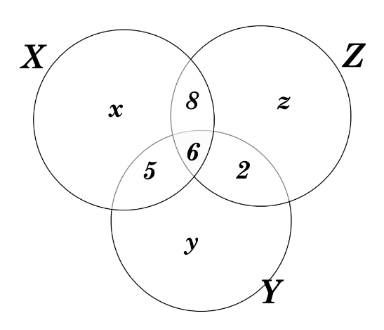

PRACTICE 2

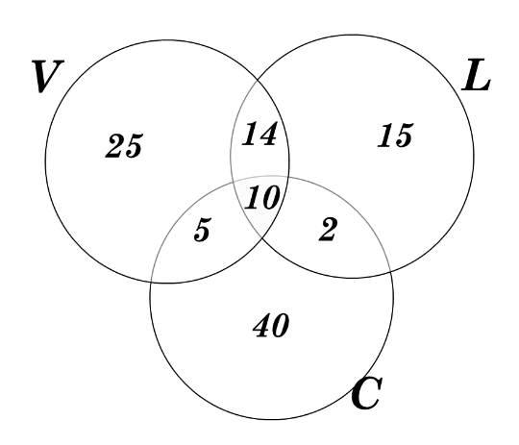
Creative Cupcakes sells vanilla (V), chocolate (C), and lemon (L) cupcakes. On Monday, customer sales were shown as in the Venn diagram. Determine each amount.
- $n(\left(V∪C\right)\backslash L)$

- $n\left(\left(L∪V\right)\backslash C\right)$

- $n\left(\left(V∪C\right)∪\left(V∪L\right)\right)$

- $n(L\backslash V\backslash C)$

PRACTICE 3

Barney is planning a tree-trekking holiday in BC. Give four words or phrases that Barney might use to search for information on the Internet. Use set theory to explain how quotation marks and the word “and” could help him refine his search.

PRACTICE 4

Terence is trying to increase sales at his pizza store. He is trying to decide whether he should offer a package deal to customers who buy pizzas and chicken wings. He hires a survey company to research consumer preferences. A survey of 500 people provides the following information: 100 buy wings, 450 buy pizza, 80 buy neither

What percent of Terence’s customers might use a package deal? Use set notation in your answer.

PRACTICE 5

A total of 55 students attend a three-day information session on working in developing countries. The three countries featured were Mali, India, and Vietnam. One country was featured per day.

- 45 attend the session on Mali, 40 on India, and 35 on Vietnam.
- 10 attended the session on Mali and India only.
- 15 attended the session on Mali and Vietnam only.
- 12 attended the session on India and Vietnam only.
- All students attended at least one session.

How many students attended all three sessions?

PRACTICE 6

There are 155 Grade 12 students at Westdale High. The number of students enrolled in the following courses is shown.

- 78 in biology
- 70 in chemistry
- 40 in physics
- 2 in all three sciences
- 20 in biology and chemistry
- 10 in chemistry and physics
- 10 in biology and physics

- Complete the Venn diagram to illustrate the situation.

- How many students do not take any of the three science courses? Explain.

